INFORMATION TECHNOLOGY  
SCHOOL BASED ASSESSMENT

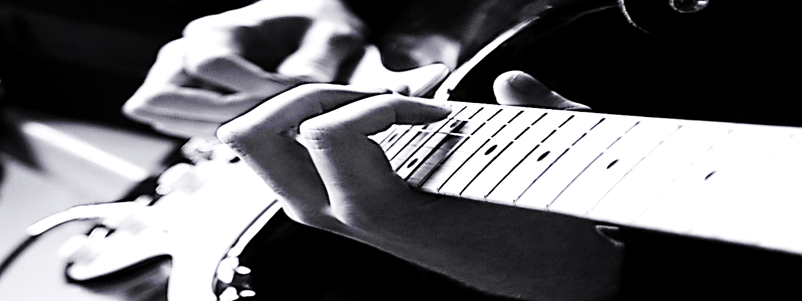

Name of Candidate: Sonny Simon Kothapally

Name of School: Central High School

School Code: 090013

Candidate Number: 0900130407

Territory: Guyana

Teacher: Ms. A. Majeed

INTRODUCTION

Carnival has been from days past, a cultural event in various Caribbean territories. Numerous masqueraders have paraded through the streets to these events. The organizers of masquerader bands utilize management and organizational skills in order to stage a successful event. As the bandleader of the Oasis Carnival Band, the researcher is in charge of:

* MS Word (the designing of flyers, and letters sent to recipients)
* MS Excel (the data of each masquerader represented on charts and spreadsheets)
* MS Access (the data of each masquerader represented on tables, queries and report)
* Ezy Pascal (the implementation of algorithm to accept masquerader data and it’s representation)

To design and implement computer-based solutions to the tasks involved in the management of the band.

ACKNOWLEDGEMENT

The researcher extends gratitude to all the various individuals who may have helped in this School Based Assessment. Every one of those individuals have contributed something of great importance in this particular SBA. It is truly hoped that their contributions are recognized by each reader who may read this assessment.

Gratitude is also handed out to those individuals who took their time off to provide valuable information. Their contributions have given the researcher a keen analysis on this topic.

And to all who take their precious time off to read this assessment.

Thank you.

SPREADsHEET

Microsoft Office Excel



MASQUERADERS 1

MASQUERADERS 2

MASQUERADERS 3

CHARTS & TABLES

DATABASE MANAGEMENT

Microsoft Office Access



Tables

Personal

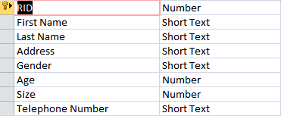

| **Personal** | | | | | | | |
| --- | --- | --- | --- | --- | --- | --- | --- |
| **RID** | **First Name** | **Last Name** | **Address** | **Gender** | **Age** | **Size** | **Telephone Number** |
| 1001 | Victor | Valdes | 1 Baker Street | Female | 27 | 4 | 223-0001 |
| 1002 | Cesc | Fabregas | 2 Grenwil Street | Female | 24 | 6 | 223-0002 |
| 1003 | Carles | Puyol | 3 Baker Street | Female | 26 | 7 | 223-0003 |
| 1004 | Andres | Iniesta | 4 Baker Street | Female | 25 | 8 | 223-0004 |
| 1005 | Alexis | Sanchez | 5 Baker Street | Male | 19 | 5 | 223-0005 |
| 1006 | Lionel | Messi | 6 Grenwil Street | Male | 28 | 5 | 223-0006 |
| 1007 | Earson | Nedd | 7 Grenwil Street | Male | 28 | 7 | 223-0007 |
| 1008 | Gerard | Pique | 8 Grenwil Street | Male | 29 | 9 | 223-0008 |
| 1009 | Martin | Montoya | 9 Baker Street | Male | 20 | 10 | 223-0009 |
| 1010 | Neymar | Da Silva | 10 Grenwil Street | Male | 29 | 14 | 223-0010 |
| 1011 | Jonathan | Dos Santos | 11 Baker Street | Male | 38 | 12 | 223-0011 |
| 1012 | Xavi | Hernandez | 12 Baker Street | Male | 37 | 5 | 223-0012 |
| 1013 | Pedro | Rodriguez | 13 Lasperdo Street | Male | 22 | 6 | 223-0013 |
| 2001 | Iker | Casillas | 14 Grenwil Street | Male | 39 | 7 | 223-0014 |
| 2002 | Kepler | Ferreira | 15 Lasperdo Street | Male | 35 | 5 | 223-0015 |
| 2003 | Karim | Benzema | 16 Baker Street | Male | 33 | 7 | 223-0016 |
| 2004 | Gareth | Bale | 17 Grenwil Street | Male | 20 | 9 | 223-0017 |
| 2005 | Sonny | Simon | 18 Lasperdo Street | Male | 30 | 7 | 223-0018 |
| 2006 | Fabio | Coentrao | 19 Baker Street | Male | 21 | 6 | 223-0019 |
| 2007 | Sergio | Ramos | 20 Grenwil Street | Male | 31 | 5 | 223-0020 |
| 2008 | Marcelo | Da Silva | 21 Lasperdo Street | Male | 21 | 7 | 223-0021 |
| 2009 | Daniel | Carvajal | 22 Baker Street | Male | 22 | 9 | 223-0022 |
| 2010 | Carlos | Casemiro | 23 Grenwil Street | Male | 32 | 7 | 223-0023 |
| 2011 | Alvaro | Arbeloa | 24 Grenwil Street | Male | 22 | 6 | 223-0024 |
| 2012 | Raphael | Varane | 25 Baker Street | Male | 30 | 5 | 223-0025 |
| 2013 | Sami | Khedira | 26 Baker Street | Male | 23 | 7 | 223-0026 |
| 2014 | Cristiano | Ronaldo | 27 Lasperdo Street | Male | 33 | 8 | 223-0027 |
| 2015 | Xabi | Alonso | 28 Grenwil Street | Male | 24 | 6 | 223-0028 |
| 2016 | Jesus | Fernandez | 29 Grenwil Street | Male | 24 | 5 | 223-0029 |
| 3001 | Jonathan | Cutting | 30 Baker Street | Male | 25 | 7 | 223-0030 |
| 3002 | Travis | Graham | 31 Baker Street | Male | 26 | 11 | 223-0031 |
| 3003 | Thulani | Hlatshwayo | 32 Baker Street | Male | 37 | 13 | 223-0032 |
| 3004 | Ritus | Krjauklis | 33 Grenwil Street | Male | 28 | 14 | 223-0033 |
| 3005 | Mosa | Lebusa | 34 Lasperdo Street | Male | 37 | 12 | 223-0034 |
| 3006 | Lebogang | Manyama | 35 Grenwil Street | Male | 28 | 11 | 223-0035 |
| 3007 | Tasreeq | Morris | 36 Baker Street | Male | 19 | 10 | 223-0036 |
| 3008 | Brandon | Peterson | 37 Baker Street | Male | 21 | 11 | 223-0037 |
| 3009 | Eleazar | Rodgers | 38 Lasperdo Street | Male | 31 | 4 | 223-0038 |
| 3010 | Matthew | Rowell | 39Grenwil Street | Male | 41 | 6 | 223-0039 |
| 3011 | Granwald | Scott | 40 Lasperdo Street | Male | 23 | 11 | 223-0040 |
| 3012 | Nhlanhla | Shabalala | 41 Baker Street | Male | 24 | 7 | 223-0041 |
| 3013 | Koen | Van De Laak | 42 Lasperdo Street | Male | 25 | 9 | 223-0042 |
| 3014 | Stefan | Van Neel | 43 Grenwil Street | Male | 53 | 7 | 223-0043 |
| 4001 | Mikel | Arteta | 44 Lasperdo Street | Male | 42 | 6 | 223-0044 |
| 4002 | Olivier | Giroud | 45 Baker Street | Male | 41 | 8 | 223-0045 |
| 4003 | Laurent | Koscielny | 46 Grenwil Street | Male | 21 | 5 | 223-0046 |
| 4004 | Mesut | Ozil | 47 Baker Street | Male | 23 | 12 | 223-0047 |
| 4005 | Lukas | Podolski | 48 Baker Street | Male | 42 | 13 | 223-0048 |
| 4006 | Tomas | Rosisky | 49 Baker Street | Male | 34 | 14 | 223-0049 |
| 4007 | Bacary | Sagna | 50 Lasperdo Street | Male | 31 | 15 | 223-0050 |
| 4008 | Wojciech | Szczesny | 51 Grenwil Street | Male | 21 | 7 | 223-0051 |
| 4009 | Thomas | Vermaelen | 52 Lasperdo Street | Male | 21 | 9 | 223-0052 |
| 4010 | Jack | Wilshere | 53 Baker Street | Male | 20 | 8 | 223-0053 |
| 5001 | Petr | Cech | 54 Grenwil Street | Male | 27 | 7 | 223-0054 |
| 5002 | Branislav | Ivanovic | 55 Grenwil Street | Male | 25 | 7 | 223-0055 |
| 5003 | David | Luiz | 56 Lasperdo Street | Male | 24 | 9 | 223-0056 |
| 5004 | Michael | Essien | 57 Lasperdo Street | Male | 26 | 6 | 223-0057 |
| 5005 | Ramirez | Nascimento | 58 Baker Street | Male | 27 | 9 | 223-0058 |
| 5006 | Frank | Lampard | 59 Lasperdo Street | Male | 24 | 5 | 223-0059 |
| 5007 | Fernando | Torres | 60 Grenwil Street | Male | 26 | 9 | 223-0060 |
| 5008 | Juan | Mata | 61 Grenwil Street | Male | 22 | 6 | 223-0061 |
| 5009 | Oscar | Dos Santos | 62 Baker Street | Male | 28 | 4 | 223-0062 |
| 5010 | John | Obi Mikel | 63 Baker Street | Male | 21 | 5 | 223-0063 |
| 5011 | Andre | Schurrle | 64 Baker Street | Male | 21 | 7 | 223-0064 |

Payment

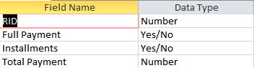

| **Payment** | | | |
| --- | --- | --- | --- |
| **RID** | **Full Payment** | **Installments** | **Total Payment** |
| 1001 | Yes | No | 294 |
| 1002 | Yes | No | 294 |
| 1003 | Yes | No | 294 |
| 1004 | Yes | No | 294 |
| 1005 | Yes | No | 294 |
| 1006 | Yes | No | 294 |
| 1007 | Yes | No | 294 |
| 1008 | No | Yes | 273 |
| 1009 | No | Yes | 234 |
| 1010 | No | Yes | 234 |
| 1011 | No | Yes | 211 |
| 1012 | Yes | No | 194 |
| 1013 | Yes | No | 194 |
| 2001 | Yes | No | 348 |
| 2002 | Yes | No | 348 |
| 2003 | Yes | No | 348 |
| 2004 | Yes | No | 348 |
| 2005 | Yes | No | 348 |
| 2006 | No | Yes | 334 |
| 2007 | No | Yes | 273 |
| 2008 | No | Yes | 273 |
| 2009 | Yes | No | 248 |
| 2010 | Yes | No | 248 |
| 2011 | Yes | No | 248 |
| 2012 | No | Yes | 234 |
| 2013 | No | Yes | 234 |
| 2014 | No | Yes | 234 |
| 2015 | No | Yes | 234 |
| 2016 | No | Yes | 111 |
| 3001 | Yes | No | 402 |
| 3002 | Yes | No | 402 |
| 3003 | Yes | No | 402 |
| 3004 | Yes | No | 402 |
| 3005 | No | Yes | 211 |
| 3006 | Yes | No | 302 |
| 3007 | Yes | No | 302 |
| 3008 | No | Yes | 273 |
| 3009 | Yes | No | 402 |
| 3010 | No | Yes | 334 |
| 3011 | Yes | No | 402 |
| 3012 | No | Yes | 173 |
| 3013 | No | Yes | 173 |
| 3014 | No | Yes | 334 |
| 4001 | Yes | No | 465 |
| 4002 | No | Yes | 111 |
| 4003 | No | Yes | 334 |
| 4004 | Yes | No | 465 |
| 4005 | Yes | No | 465 |
| 4006 | No | Yes | 173 |
| 4007 | Yes | No | 465 |
| 4008 | Yes | No | 465 |
| 4009 | Yes | No | 465 |
| 4010 | Yes | No | 465 |
| 5001 | No | Yes | 334 |
| 5002 | Yes | No | 532 |
| 5003 | Yes | No | 532 |
| 5004 | Yes | No | 532 |
| 5005 | Yes | No | 532 |
| 5006 | Yes | No | 432 |
| 5007 | Yes | No | 432 |
| 5008 | Yes | No | 532 |
| 5009 | No | Yes | 334 |
| 5010 | Yes | No | 532 |
| 5011 | Yes | No | 532 |

Section



| **Section** | |
| --- | --- |
| **RID** | **Section ID** |
| 1001 | 1000 |
| 1002 | 1000 |
| 1003 | 1000 |
| 1004 | 1000 |
| 1005 | 1000 |
| 1006 | 1000 |
| 1007 | 1000 |
| 1008 | 1000 |
| 1009 | 1000 |
| 1010 | 1000 |
| 1011 | 1000 |
| 1012 | 1000 |
| 1013 | 1000 |
| 2001 | 2000 |
| 2002 | 2000 |
| 2003 | 2000 |
| 2004 | 2000 |
| 2005 | 2000 |
| 2006 | 2000 |
| 2007 | 2000 |
| 2008 | 2000 |
| 2009 | 2000 |
| 2010 | 2000 |
| 2011 | 2000 |
| 2012 | 2000 |
| 2013 | 2000 |
| 2014 | 2000 |
| 2015 | 2000 |
| 2016 | 2000 |
| 3001 | 3000 |
| 3002 | 3000 |
| 3003 | 3000 |
| 3004 | 3000 |
| 3005 | 3000 |
| 3006 | 3000 |
| 3007 | 3000 |
| 3008 | 3000 |
| 3009 | 3000 |
| 3010 | 3000 |
| 3011 | 3000 |
| 3012 | 3000 |
| 3013 | 3000 |
| 3014 | 3000 |
| 4001 | 4000 |
| 4002 | 4000 |
| 4003 | 4000 |
| 4004 | 4000 |
| 4005 | 4000 |
| 4006 | 4000 |
| 4007 | 4000 |
| 4008 | 4000 |
| 4009 | 4000 |
| 4010 | 4000 |
| 5001 | 5000 |
| 5002 | 5000 |
| 5003 | 5000 |
| 5004 | 5000 |
| 5005 | 5000 |
| 5006 | 5000 |
| 5007 | 5000 |
| 5008 | 5000 |
| 5009 | 5000 |
| 5010 | 5000 |
| 5011 | 5000 |

Queries

GiftVoucher

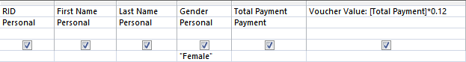

| **GiftVoucher** | | | | | |
| --- | --- | --- | --- | --- | --- |
| **RID** | **First Name** | **Last Name** | **Gender** | **Total Payment** | **Voucher Value** |
| 1001 | Victor | Valdes | Female | 294 | 35.28 |
| 1002 | Cesc | Fabregas | Female | 294 | 35.28 |
| 1003 | Carles | Puyol | Female | 294 | 35.28 |
| 1004 | Andres | Iniesta | Female | 294 | 35.28 |

Paidup

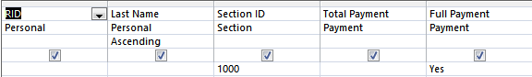

| **Paidup** | | | | |
| --- | --- | --- | --- | --- |
| **RID** | **Last Name** | **Section ID** | **Total Payment** | **Full Payment** |
| 1002 | Fabregas | 1000 | 294 | Yes |
| 1012 | Hernandez | 1000 | 194 | Yes |
| 1004 | Iniesta | 1000 | 294 | Yes |
| 1006 | Messi | 1000 | 294 | Yes |
| 1007 | Nedd | 1000 | 294 | Yes |
| 1003 | Puyol | 1000 | 294 | Yes |
| 1013 | Rodriguez | 1000 | 194 | Yes |
| 1005 | Sanchez | 1000 | 294 | Yes |
| 1001 | Valdes | 1000 | 294 | Yes |

Rebate

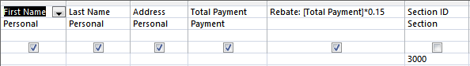

| **Rebate** | | | | |
| --- | --- | --- | --- | --- |
| **First Name** | **Last Name** | **Address** | **Total Payment** | **Rebate** |
| Jonathan | Cutting | 30 Baker Street | 402 | 60.3 |
| Travis | Graham | 31 Baker Street | 402 | 60.3 |
| Thulani | Hlatshwayo | 32 Baker Street | 402 | 60.3 |
| Ritus | Krjauklis | 33 Grenwil Street | 402 | 60.3 |
| Mosa | Lebusa | 34 Lasperdo Street | 211 | 31.65 |
| Lebogang | Manyama | 35 Grenwil Street | 302 | 45.3 |
| Tasreeq | Morris | 36 Baker Street | 302 | 45.3 |
| Brandon | Peterson | 37 Baker Street | 273 | 40.95 |
| Eleazar | Rodgers | 38 Lasperdo Street | 402 | 60.3 |
| Matthew | Rowell | 39Grenwil Street | 334 | 50.1 |
| Granwald | Scott | 40 Lasperdo Street | 402 | 60.3 |
| Nhlanhla | Shabalala | 41 Baker Street | 173 | 25.95 |
| Koen | Van De Laak | 42 Lasperdo Street | 173 | 25.95 |
| Stefan | Van Neel | 43 Grenwil Street | 334 | 50.1 |

Section1

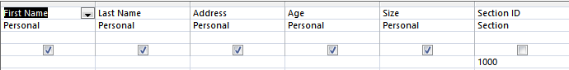

| **Section 1** | | | | |
| --- | --- | --- | --- | --- |
| **First Name** | **Last Name** | **Address** | **Age** | **Size** |
| Victor | Valdes | 1 Baker Street | 27 | 4 |
| Cesc | Fabregas | 2 Grenwil Street | 24 | 6 |
| Carles | Puyol | 3 Baker Street | 26 | 7 |
| Andres | Iniesta | 4 Baker Street | 25 | 8 |
| Alexis | Sanchez | 5 Baker Street | 19 | 5 |
| Lionel | Messi | 6 Grenwil Street | 28 | 5 |
| Earson | Nedd | 7 Grenwil Street | 28 | 7 |
| Gerard | Pique | 8 Grenwil Street | 29 | 9 |
| Martin | Montoya | 9 Baker Street | 20 | 10 |
| Neymar | Da Silva | 10 Grenwil Street | 29 | 14 |
| Jonathan | Dos Santos | 11 Baker Street | 38 | 12 |
| Xavi | Hernandez | 12 Baker Street | 37 | 5 |
| Pedro | Rodriguez | 13 Lasperdo Street | 22 | 6 |

Twenties Ladies

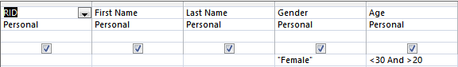

| **Twenties Ladies** | | | | |
| --- | --- | --- | --- | --- |
| **RID** | **First Name** | **Last Name** | **Gender** | **Age** |
| 1001 | Victor | Valdes | Female | 27 |
| 1002 | Cesc | Fabregas | Female | 24 |
| 1003 | Carles | Puyol | Female | 26 |
| 1004 | Andres | Iniesta | Female | 25 |

Delete

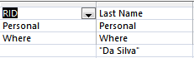

| **Delete** | |
| --- | --- |
| **RID** | **Last Name** |
| 1010 | Da Silva |
| 2008 | Da Silva |

Report Query

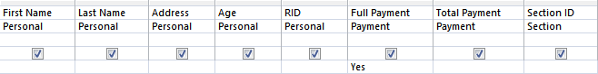

| **Report Query** | | | | | | | |
| --- | --- | --- | --- | --- | --- | --- | --- |
| **First Name** | **Last Name** | **Address** | **Age** | **RID** | **Full Payment** | **Total Payment** | **Section ID** |
| Victor | Valdes | 1 Baker Street | 27 | 1001 | Yes | 294 | 1000 |
| Cesc | Fabregas | 2 Grenwil Street | 24 | 1002 | Yes | 294 | 1000 |
| Carles | Puyol | 3 Baker Street | 26 | 1003 | Yes | 294 | 1000 |
| Andres | Iniesta | 4 Baker Street | 25 | 1004 | Yes | 294 | 1000 |
| Alexis | Sanchez | 5 Baker Street | 19 | 1005 | Yes | 294 | 1000 |
| Lionel | Messi | 6 Grenwil Street | 28 | 1006 | Yes | 294 | 1000 |
| Earson | Nedd | 7 Grenwil Street | 28 | 1007 | Yes | 294 | 1000 |
| Xavi | Hernandez | 12 Baker Street | 37 | 1012 | Yes | 194 | 1000 |
| Pedro | Rodriguez | 13 Lasperdo Street | 22 | 1013 | Yes | 194 | 1000 |
| Iker | Casillas | 14 Grenwil Street | 39 | 2001 | Yes | 348 | 2000 |
| Kepler | Ferreira | 15 Lasperdo Street | 35 | 2002 | Yes | 348 | 2000 |
| Karim | Benzema | 16 Baker Street | 33 | 2003 | Yes | 348 | 2000 |
| Gareth | Bale | 17 Grenwil Street | 20 | 2004 | Yes | 348 | 2000 |
| Sonny | Simon | 18 Lasperdo Street | 30 | 2005 | Yes | 348 | 2000 |
| Daniel | Carvajal | 22 Baker Street | 22 | 2009 | Yes | 248 | 2000 |
| Carlos | Casemiro | 23 Grenwil Street | 32 | 2010 | Yes | 248 | 2000 |
| Alvaro | Arbeloa | 24 Grenwil Street | 22 | 2011 | Yes | 248 | 2000 |
| Jonathan | Cutting | 30 Baker Street | 25 | 3001 | Yes | 402 | 3000 |
| Travis | Graham | 31 Baker Street | 26 | 3002 | Yes | 402 | 3000 |
| Thulani | Hlatshwayo | 32 Baker Street | 37 | 3003 | Yes | 402 | 3000 |
| Ritus | Krjauklis | 33 Grenwil Street | 28 | 3004 | Yes | 402 | 3000 |
| Lebogang | Manyama | 35 Grenwil Street | 28 | 3006 | Yes | 302 | 3000 |
| Tasreeq | Morris | 36 Baker Street | 19 | 3007 | Yes | 302 | 3000 |
| Eleazar | Rodgers | 38 Lasperdo Street | 31 | 3009 | Yes | 402 | 3000 |
| Granwald | Scott | 40 Lasperdo Street | 23 | 3011 | Yes | 402 | 3000 |
| Mikel | Arteta | 44 Lasperdo Street | 42 | 4001 | Yes | 465 | 4000 |
| Mesut | Ozil | 47 Baker Street | 23 | 4004 | Yes | 465 | 4000 |
| Lukas | Podolski | 48 Baker Street | 42 | 4005 | Yes | 465 | 4000 |
| Bacary | Sagna | 50 Lasperdo Street | 31 | 4007 | Yes | 465 | 4000 |
| Wojciech | Szczesny | 51 Grenwil Street | 21 | 4008 | Yes | 465 | 4000 |
| Thomas | Vermaelen | 52 Lasperdo Street | 21 | 4009 | Yes | 465 | 4000 |
| Jack | Wilshere | 53 Baker Street | 20 | 4010 | Yes | 465 | 4000 |
| Branislav | Ivanovic | 55 Grenwil Street | 25 | 5002 | Yes | 532 | 5000 |
| David | Luiz | 56 Lasperdo Street | 24 | 5003 | Yes | 532 | 5000 |
| Michael | Essien | 57 Lasperdo Street | 26 | 5004 | Yes | 532 | 5000 |
| Ramirez | Nascimento | 58 Baker Street | 27 | 5005 | Yes | 532 | 5000 |
| Frank | Lampard | 59 Lasperdo Street | 24 | 5006 | Yes | 432 | 5000 |
| Fernando | Torres | 60 Grenwil Street | 26 | 5007 | Yes | 432 | 5000 |
| Juan | Mata | 61 Grenwil Street | 22 | 5008 | Yes | 532 | 5000 |
| John | Obi Mikel | 63 Baker Street | 21 | 5010 | Yes | 532 | 5000 |
| Andre | Schurrle | 64 Baker Street | 21 | 5011 | Yes | 532 | 5000 |

Relationships

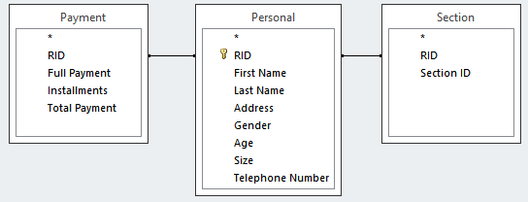

Report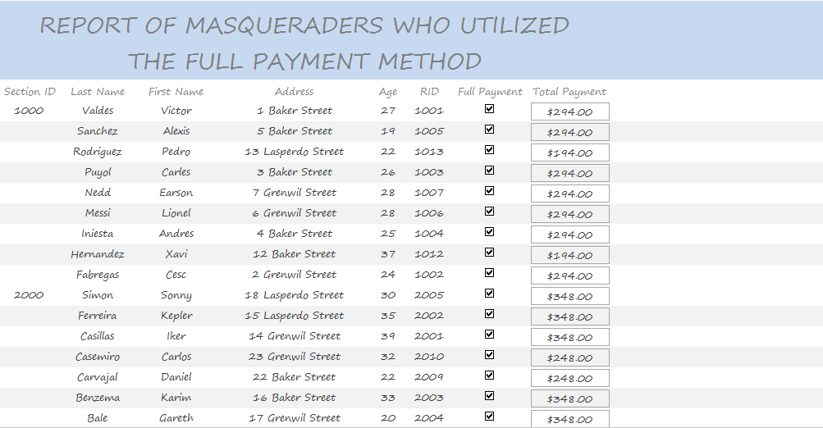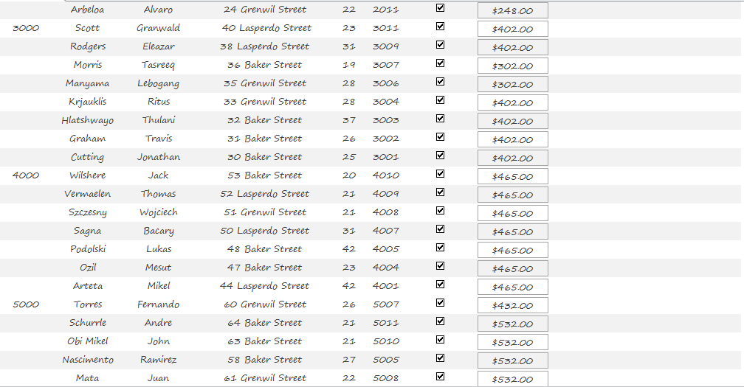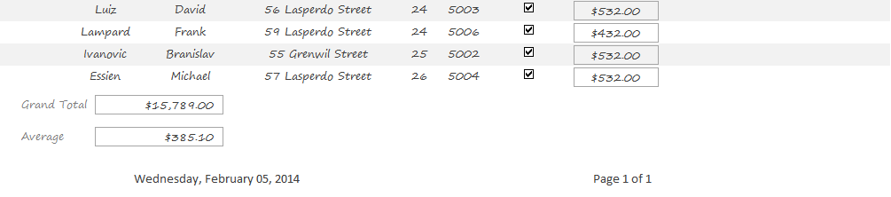

WORD PROCESSING

Microsoft Office Word



OASIS CARNIVAL BAND

www.oasis-band-international.com

TEL: 888-8888

9th September 2013

Dear Mr. /Ms. ,

This letter is to inform you that our band will have to assemble at Smyth Street to commence our march to Orange Walk along Brickdam at 12:45 PM. We of the Oasis Carnival Band humbly thank you for using the Full Payment method to deposit your capital for our services.

Enclosed on the next page is a report showing all the masqueraders who paid in full for the costumes for their respective sections.

We are grateful for your decision to participate in our band’s carnival events. We hope that your participation will benefit us tremendously and trust that you will follow our band in the years to come.

Thanking You,

sonnyksimon

(Band Leader)

OASIS CARNIVAL BAND

www.oasis-band-international.com

TEL: 888-8888

9th September 2013

Dear Mr. /Ms. ,

This letter is to inform you that our band will have to assemble at Smyth Street to commence our march to Orange Walk along Brickdam at 12:45 PM. We of the Oasis Carnival Band humbly thank you for using the Full Payment method to deposit your capital for our services.

Enclosed on the next page is a report showing all the masqueraders who paid in full for the costumes for their respective sections.

We are grateful for your decision to participate in our band’s carnival events. We hope that your participation will benefit us tremendously and trust that you will follow our band in the years to come.

Thanking You,

sonnyksimon

(Band Leader)

OASIS CARNIVAL BAND

www.oasis-band-international.com

TEL: 888-8888

9th September 2013

Dear Mr. /Ms. ,

This letter is to inform you that our band will have to assemble at Smyth Street to commence our march to Orange Walk along Brickdam at 12:45 PM. We of the Oasis Carnival Band humbly thank you for using the Full Payment method to deposit your capital for our services.

Enclosed on the next page is a report showing all the masqueraders who paid in full for the costumes for their respective sections.

We are grateful for your decision to participate in our band’s carnival events. We hope that your participation will benefit us tremendously and trust that you will follow our band in the years to come.

Thanking You,

sonnyksimon

(Band Leader)

OASIS CARNIVAL BAND

www.oasis-band-international.com

TEL: 888-8888

9th September 2013

Dear Mr. /Ms. ,

This letter is to inform you that our band will have to assemble at Smyth Street to commence our march to Orange Walk along Brickdam at 12:45 PM. We of the Oasis Carnival Band humbly thank you for using the Full Payment method to deposit your capital for our services.

Enclosed on the next page is a report showing all the masqueraders who paid in full for the costumes for their respective sections.

We are grateful for your decision to participate in our band’s carnival events. We hope that your participation will benefit us tremendously and trust that you will follow our band in the years to come.

Thanking You,

sonnyksimon

(Band Leader)

PROBLEM SOLVING

Ezy Pascal

http://img.informer.com/icons/png/48/3507/3507417.png

IPO Chart

|  |  |  |
| --- | --- | --- |
| Input | Processing | Output |
| n, c | Repeat until a condition is met  Assign to section  Initiate p1,p2...p5  Assign n to c1[p1],c2[p2]…c5[p5]  Calculate t1,t2,t3,t4,t5 | Print t1,p1,c1  Print t2,p2,c2  Print t3,p3,c3  Print t4,p4,c4  Print t5,p5,c5 |

Variable Table

|  |  |
| --- | --- |
| Variable | Purpose |
| p1,p2,p3,p4,p5 | Stores the number of masqueraders in a section |
| c1,c2,c3,c4,c5 | To store the names in an array of p1,p2,p3,p4,p5 |
| i | Stores the amount of loops |
| d | Stores the section required to display |
| x | Stops/starts the repeat function |
| p | Repeats the display section screen |
| n | Stores the name of the masquerader |
| c | Stores the cost of the masquerader |
| t1,t2,t3,t4,t5 | Stores the total for each section |

Algorithm

start

x:=2

p1:=0

p2:=0

p3:=0

p4:=0

p5:=0

repeat

enter n,c

if c=160 then

p1:=p1+1

c1[p1]:=n

else

if c=220 then

p2:=p2+1

c2[p2]:=n

else

if c=280 then

p3:=p3+1

c3[p3]:=n

else

if c=350 then

p4:=p4+1

c4[p4]:=n

else

if c=425 then

p5:=p5+1

c5[p5]:=n

endif

enter x

until x=3

t1:=p1*160

t2:=p2*220

t3:=p3*280

t4:=p4*350

t5:=p5*425

print t1,p1,c1

print t2,p2,c2

print t3,p3,c3

print t4,p4,c4

print t5,p5,c5

stop

TraceTable

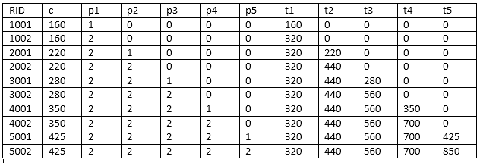

start

Flowchart

x:=2

p1:=0

p2:=0

p3:=0

p4:=0

p5:=0

repeat

enter n,c

if c=160 then

No

Yes

p1:=p1+1

c1[p1]:=n

if c=220 then

No

Yes

p2:=p2+1

c2[p2]:= n

if c=280 then

No

Yes

p3:=p3+1

c3[p3]:=n

if c=350 then

No

Yes

p4:=p4+1

c4[p4]:=n

if c=425 then

Yes

p5:=p5+1

c5[p5]:=n

enter x

until x=3

t1: =p1*160

t2:=p2*220

t3:=p3*280

t4:=p4*350

t5:=p5*425

print t1,p1,c1

print t2,p2,c2

print t3,p3,c3

print t4,p4,c4

print t5,p5,c5

stop

Program Code

program prog_CXC;

var

c1,c2,c3,c4,c5: Array[1..15] of string;

p1,p2,p3,p4,p5,z,x,i,d,l,p,q:integer;

c,t1,t2,t3,t4,t5:real;

n:string;

begin

p:=1;

x:=2;

p1:=0;

p2:=0;

p3:=0;

p4:=0;

p5:=0;

z:=1;

repeat

begin

Write('Name:');

readln(n);

Write('Cost:');

readln(c);

if c=160 then

begin

p1:=p1+1;

c1[p1]:=n;

end;

if c=220 then

begin

p2:=p2+1;

c2[p2]:=n;

end;

if c=280 then

begin

p3:=p3+1;

c3[p3]:=n;

end;

if c=350 then

begin

p4:=p4+1;

c4[p4]:=n;

end;

if c=425 then

begin

p5:=p5+1;

c5[p5]:=n;

end;

writeln('Please Enter 3 to End Program or any other number to Continue');

readln(x);

end;

until x=3;

writeln('');

writeln('');

t1:=p1*160;

t2:=p2*220;

t3:=p3*280;

t4:=p4*350;

t5:=p5*425;

repeat

begin

Writeln('Please enter:');

Writeln('1 to display Section 1');

Writeln('2 to display Section 2');

Writeln('3 to display Section 3');

Writeln('4 to display Section 4');

Writeln('5 to display Section 5');

Writeln('0 to display All Sections');

Readln(d);

if d=1 then

begin

writeln('Section 1 Total:',t1:5:0);

writeln('Masqueraders:',p1);

for i:=1 to p1 do;

begin

writeln('Name(s):');

writeln(c1[i]);

writeln('');

end;

end;

if d=2 then

begin

writeln('Section 2 Total:',t2:5:0);

writeln('Masqueraders:',p2);

for i:=1 to p2 do;

begin

writeln('Name(s):');

writeln(c2[i]);

writeln('');

end;

end;

if d=3 then

begin

writeln('Section 3 Total:',t3:5:0);

writeln('Masqueraders:',p3);

for i:=1 to p3 do;

begin

writeln('Name(s):');

writeln(c3[i]);

writeln('');

end;

end;

if d=4 then

begin

writeln('Section 4 Total:',t4:5:0);

writeln('Masqueraders:',p4);

for i:=1 to p4 do;

begin

writeln('Name(s):');

writeln(c4[i]);

writeln('');

end;

end;

if d=5 then

begin

writeln('Section 5 Total:',t5:5:0);

writeln('Masqueraders:',p5);

for i:=1 to p5 do;

begin

writeln('Name(s):');

writeln(c5[i]);

writeln('');

end;

end;

if d=0 then

begin

writeln('Section 1 Total:',t1:5:0);

writeln('Masqueraders:',p1);

for i:=1 to p1 do;

begin

writeln('Name(s):');

writeln(c1[i]);

writeln('');

end;

writeln('Section 2 Total:',t2:5:0);

writeln('Masqueraders:',p2);

for i:=1 to p2 do;

begin

writeln('Name(s):');

writeln(c2[i]);

writeln('');

end;

writeln('Section 3 Total:',t3:5:0);

writeln('Masqueraders:',p3);

for i:=1 to p3 do;

begin

writeln('Name(s):');

writeln(c3[i]);

writeln('');

end;

writeln('Section 4 Total:',t4:5:0);

writeln('Masqueraders:',p4);

for i:=1 to p4 do;

begin

writeln('Name(s):');

writeln(c4[i]);

writeln('');

end;

writeln('Section 5 Total:',t5:5:0);

writeln('Masqueraders:',p5);

for i:=1 to p5 do;

begin

writeln('Name(s):');

writeln(c5[i]);

writeln('');

end;

end;

Writeln('Enter 1 to stop');

readln(p);

end;

until p=1;

Writeln('');

Writeln('Thank You for Using Our Program');

end.

Program in Ezy Pascal 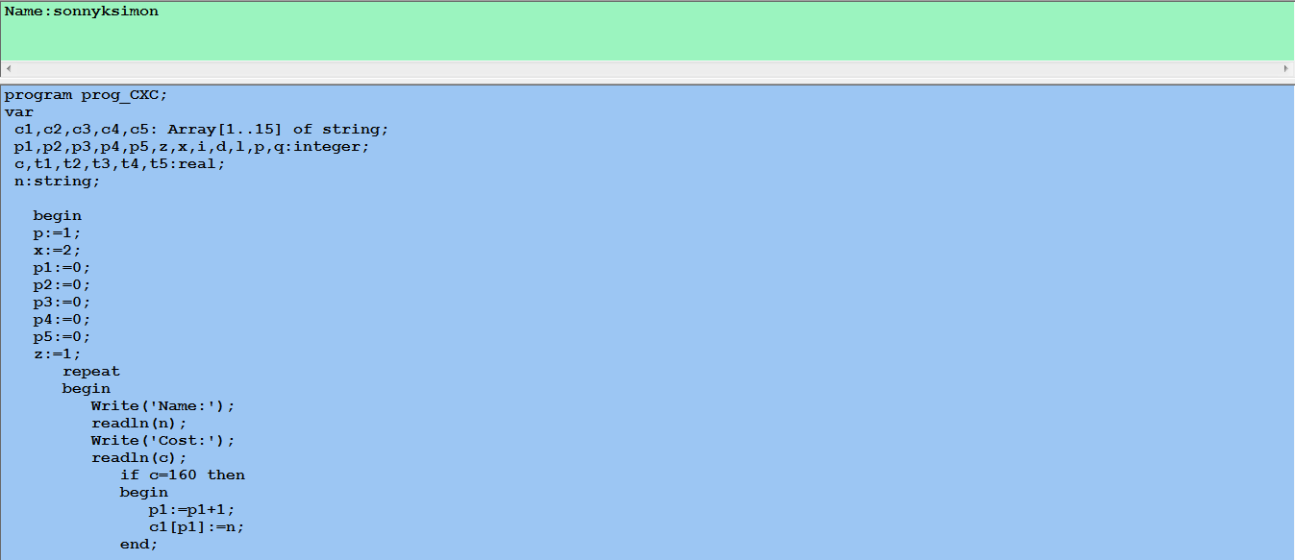 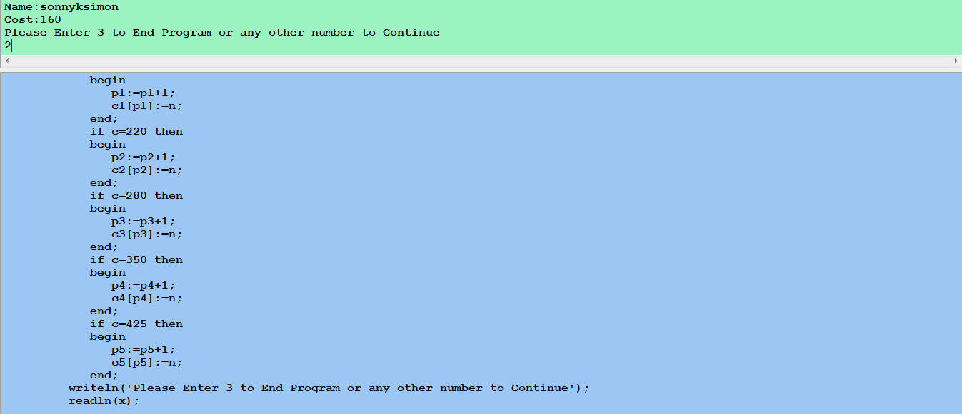 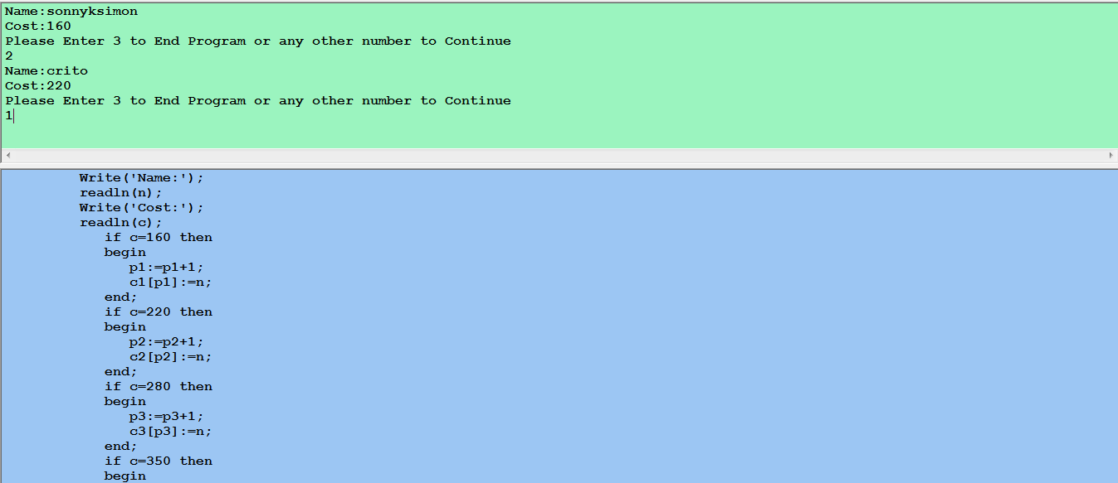

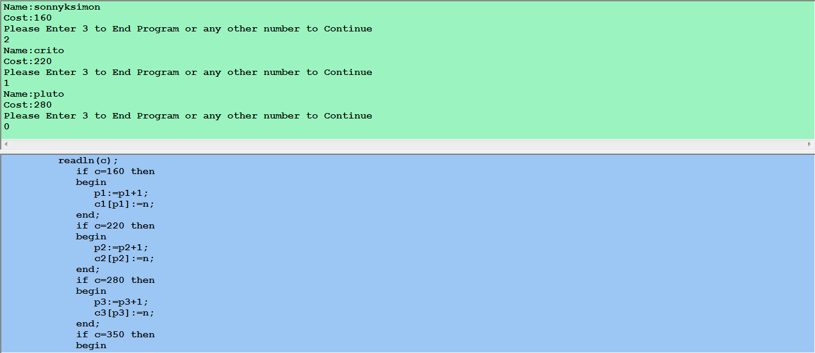 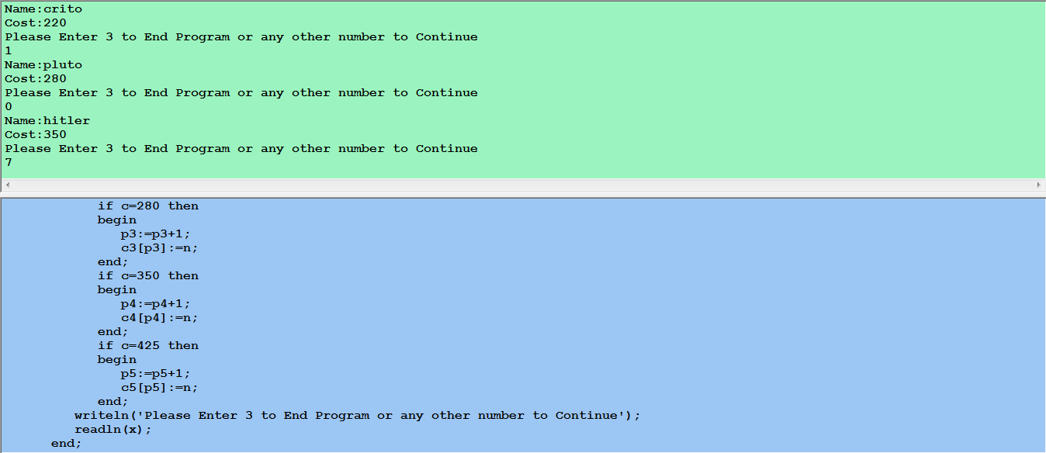 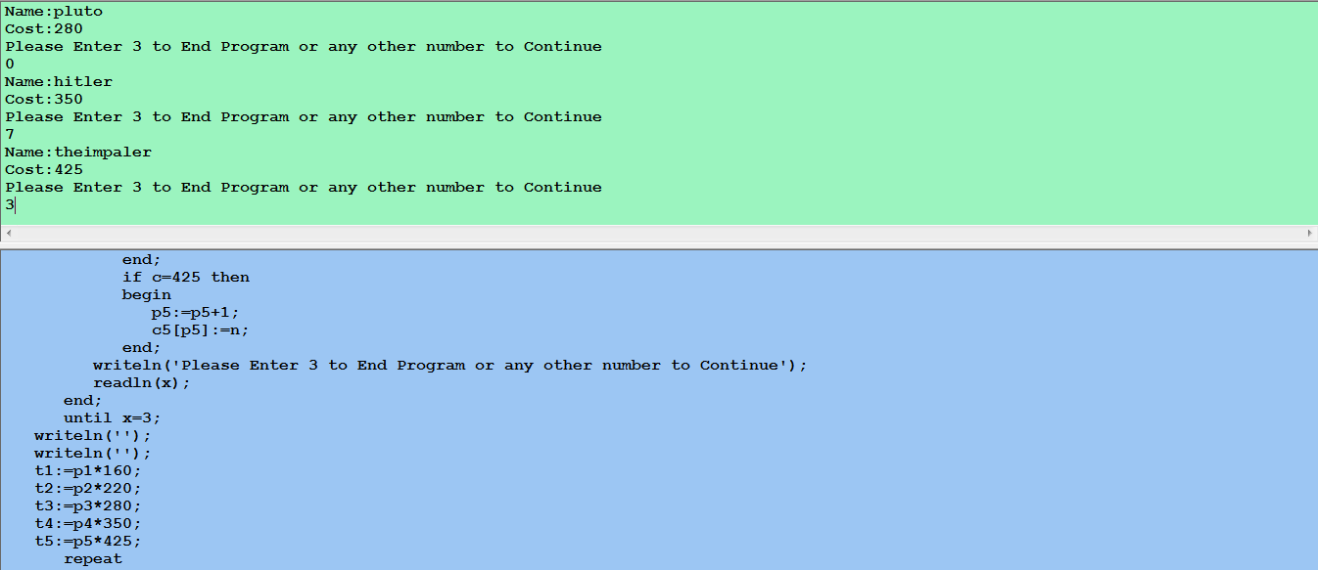 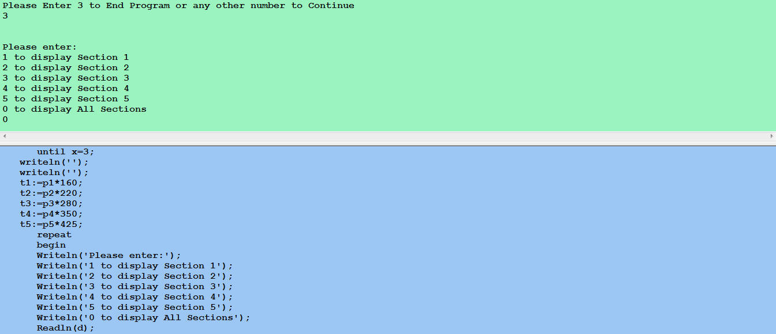 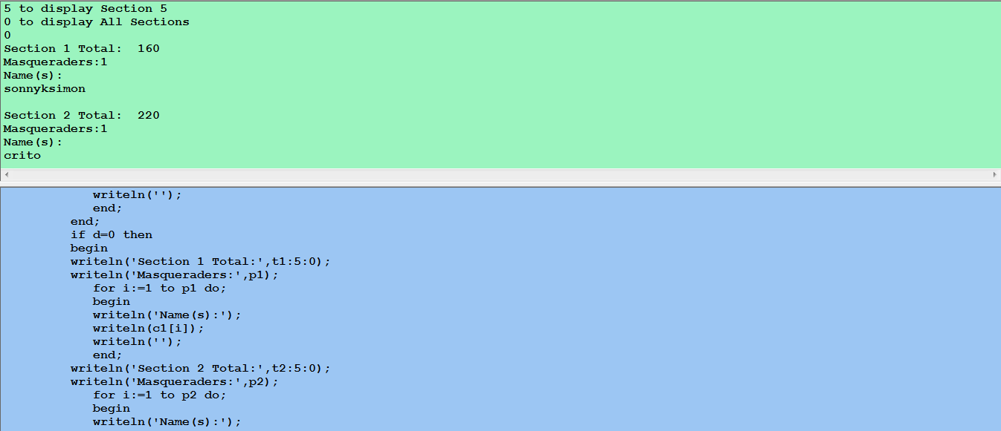 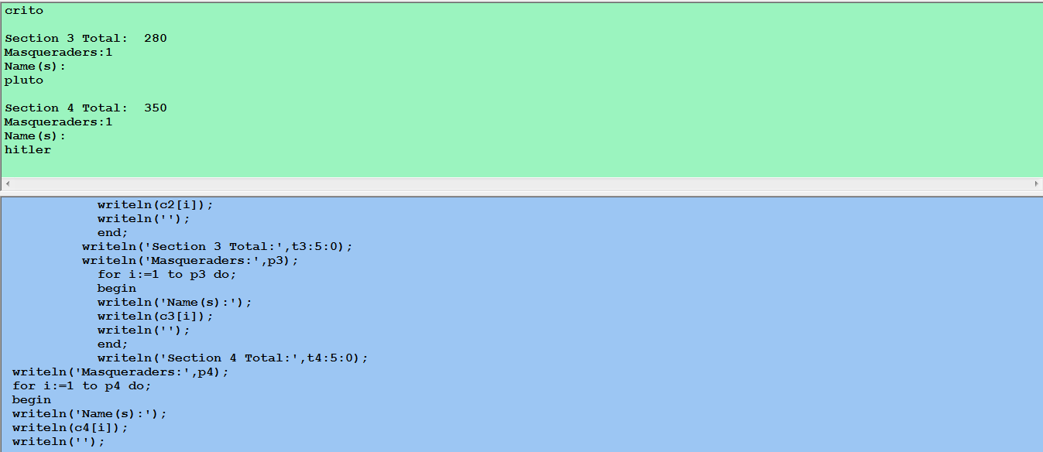 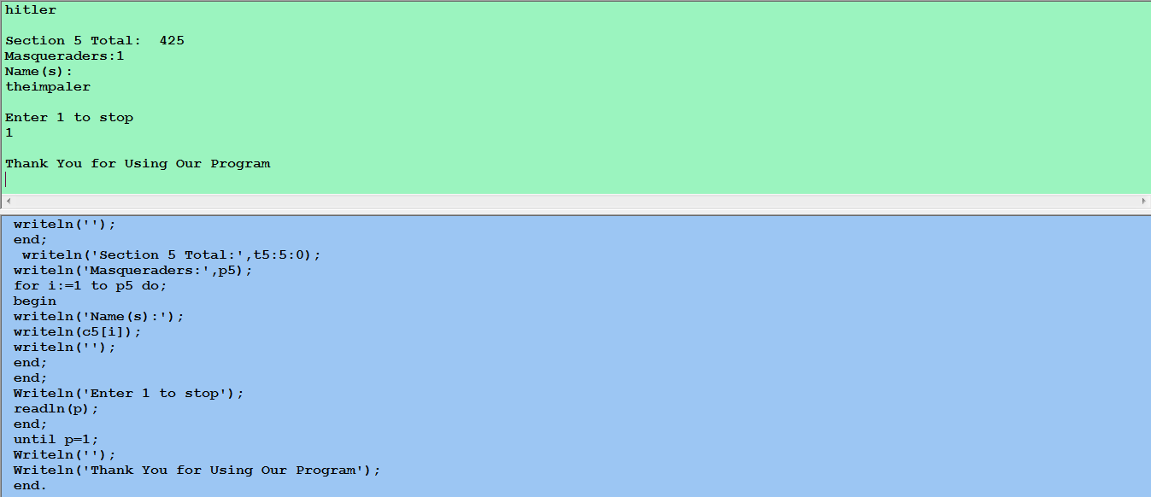

Conclusion

In this project, it was learnt that:

* MS Word is a word processor and can be used to efficiently complete the flyer and the letters. It was rather simple to use innovative fonts and sizes as compared to that of Notepad/WordPad.
* MS Excel has lots of options when designing charts and the tables and reduces time drastically with its various functions and formulas.
* MS Access is the best option to store data as queries and reports can be created almost instantaneously and is very similar to Excel in appearance and also stores it in the same format.
* Ezy Pascal is completely programmable and is structured to easily implement an algorithm in it and has proved to be very influential.